A Project Report on

**E-SEVA APPLICATION**

Submitted by

**AMOD AHER (SS17CO005)**

**AMAN GADADARE (SS17CO006)**

**SHREYAS LOKHANDE (SS17CO009)**

**PRATHAMESH ADAKE (SS17CO015)**

**In partial fulfillment of the requirements for**

**Diploma in Computer Engineering**

**2017-18**

Under the guidance of

**Prof. Pooja S. Chame**



**Department of Computer Engineering**

**Government Polytechnic, Mumbai**

**Mumbai-400051**





**Department of Computer Engineering**

**Government Polytechnic, Mumbai**

Mumbai-400051

CERTIFICATE

This is to certify that following students have successfully and satisfactorily completed the project on **“E-Seva”** and presented their report in the partial fulfillment of requirement for Diploma in Computer Engineering from Government Polytechnic, Mumbai under the guidance of **Prof. Pooja S. Chame** in the academic year 2017-2018.

**AMOD AHER (SS17CO005)**

**AMAN GADADARE (SS17CO006)**

**SHREYAS LOKHANDE (SS17CO009)**

**PRATHAMESH ADAKE (SS17CO015)**

| Project Guide |  | External Examiner |
| --- | --- | --- |
| Head Of the Department |  | Principal |

ACKNOWLEDGEMENT

It is always a difficult job to acknowledge all those who have been of tremendous help in the development of any work. In spite of that, we honestly thanks all those who have put in tremendous efforts in guiding and helping us to successfully build this project named **“E-SEVA”**. We take this opportunity to thank each and every one for their cooperation and support.

First and firmly we are grateful to **Mrs. Swati D. Deshpande** (Principal, Government Polytechnic Mumbai) for allowing us to this project collectively and with advanced techniques.

We express our sincere gratitude towards **Prof. V. M. Aswar** (Head of Computer Department).

We are thankful to **Prof. Pooja S. Chame** our project guide for their valuable guidance throughout, without which the project would not have stood it’s ground as it has now. We would even like to thank people who have directly or indirectly helped us with the making of the project and their support.

CONTENTS

| **SR.NO** | **TITLE** |  |
| --- | --- | --- |
| **-** | **Abstract** |  |
| 1. | Introduction |  |
| 2. | Feasibility Study |  |
| 3. | Project Planning |  |
| 4. | Requirement Analysis |  |
| 5. | System Design |  |
| 6. | Database Structure |  |
| 7. | Coding |  |

**ABSTRACT**

The main objective of this “E-SEVA” app project is to develop an android application which will solve people’s day-to-day life problems. This app acts as an interface between Corporator and Local Residents. In this application there are 2 main sections which are sub-divided further as following:

1. **User Module**

**Home**

* Recruitment
* Complaints
* Events
* Environment
* Special Services for Women
* Know your Corporator

**Schemes**

* Subsidy for Ration
* Echo housing
* Schemes for student

1. **Corporator Module**

The Local Residents can file complaints about various issues in their residents like Water, Road (Potholes), Illegal vehicle parking, Access Pollution etc. problems. The Corporator will know the complaints and take remedial actions to solve these problems.

CHAPTER 1

Introduction

Introduction

1. **User Module:**

There will be home page where user can login, after login, it redirects to

Another page which consists of two forms where

1. User will create its profile.

2. User will enter his all necessary info (ward no, address pin code, etc.).

On Clicking Register button, the user account will be created, now user can make use of further application.

* 1. **Complaint Section:**

On Clicking Complaint section user can file for different types of complaints in his/her residents.

For this user has to fill form or can fill the letter with appropriate information.

Problems:

1. Electricity Shortage
2. Water Shortage
3. Water Lodging
4. Drainage Problem
5. Illegal Vehicle Parking
6. Access Pollution
   1. **Services for women:**

In these section user can see all services provided by the Brihanmumbai Municipal Corporation (**BMC)** to women .Inwhich there will be “Women service poll” etc.

This section will include schemes for women like:

**1. Women Entrepreneurship program**

**2. Sexual Harassment**

**3. Schemes for Women**

1. Manjhi Kanya Bhagyashree Scheme

2. Beti Bachao Beti Padhao Scheme

3. Rajiv Gandhi National Creche Scheme for the Children of Working Mothers

4. SavitribaiPhule Multipurpose Women's Centre for victims of atrocities

**4. Sukanya Yojna**

* 1. **Environment Section:**

The Environment section consists of the needful for the citizens to do to keep their surroundings healthy and free from pollution and diseases.

* 1. **Recruitment Section:**

This section includes jobs and vacancies form nearby corporate offices, general stores listed.

* 1. **Events:**

Events section consists of events organized by the government and NGO’s for social welfare of society.

1. **Corporator Module:**

Corporator can login to the application providing id and password given by

Corporation IT department after logging in, the Corporator can see all complaints and problems filled by peoples and thus after will start his further next procedure to resolve the problem.

The Corporator section will include the following where he/she can view the problems in the respective sections filled by the citizens:

1. Electricity Shortage
2. Water Shortage
3. Water Lodging
4. Drainage Problem
5. Illegal Vehicle Parking
6. Access Pollution

CHAPTER 2

Feasibility Study

Feasibility Study

**2.1 Go native:**

The best user experience can be achieved only when using the native development environment. Apps built using cross-platform development tools will not cut it.

**2.2 Remember form factors:**

Your app will be run on phones from different manufacturers, with different size of displays and resolutions, on portrait and landscape as well as on tablets and possibly e-readers. Don’t hard-code your screen layouts with a specific form factor or phone in mind.

**2.3 Support as many versions as possible:**

Android OS versions are coming out thick and fast, as are the phones. At any time, expect your target user base to be spread across at least 3 different OS versions.

**2.4 Be prepared for missing components:**

Not all devices have all the bells and whistles such as front cameras, accelerometers, and gyroscopes. Use them in your apps, by all means, but don’t depend on their presence either.

**2.5Sticktothebasics:**

Most people understand standard android app behavior – so follow the same standards. For example, if your app has a menu, it has to be accessible from the menu button.

**2.6 Be prepared for lack of connectivity:**

Connections on mobile phones will drop, Program defensively for such situations.

**2.7 No time-consuming processing in the UI thread:**

Use multi-threading wisely and avoid holding up the UI/main thread. Even a sub 2 second frozen screen is enough the turn a customer away

**2.8 Don’t hog the resources:**

The Android phone is thin on resources and it has to be shared between all the apps. Plus, Android provides users with easy access to data such as how much memory and battery you app is consuming. As it is, most of the Android phones have to be re-charged every day. If your app is seen to be draining a lot of the battery, it will be the first to be un-installed.

**2.9 Don’t force users to login every time:**

Typing is never easy, even with Swipe Pad installed. If the user has to login to access the app functionality every time, your app will never get used. Avoid login altogether if you can. If you can’t, then provide an explicit logout and leave it to the user to decide whether she wants to be permanently logged in or not. Remember, a phone is a personal device and most often not shared with anybody else. How many times have you logged into gmail from your Android? Imagine if you had to go through the login process every time!

2.9.1. Technically and legally viable

Application provides the authentication for each module. This assures the information will be secure for all modules.

2.9.2. Economically viable

As Android Studio is an open source mobile platform, proposed system is cost efficient as well as it is easily available in the format of .apk file, admin can easily make changes in the code without any hectic procedure and can share that updated application.

CHAPTER 3

Project Planning

# Project Planning

The overall Project Design consists of: -

1. Requirement Gathering:

Requirements Gathering or Capture is the process of generating a list of requirements (functional, system, technical, etc.) from the various stakeholders (Corporators, Users, IT staff, etc.)

1. Setting and Prioritizing Goals:

Once you have a list of user’s needs, prioritize them and set specific project goals. These should outline project objectives, or the metrics and benefits you hope to achieve. Compare the goals and the user’s needs they address in proposed project plan so it clearly communicated and easily shareable.

1. Identify Issues and Complete a Risk Assessment

Tackle high-risk items and problem early in your project timeline, if possible. Try to figure out and find solution about how overcome that problem and remain that application safe and secure.

**XML**

Extensible Markup Language (XML) is a markup language that defines a set of rules for encoding documents in a format that is both human-readable and machine- readable. The design goals of XML emphasize simplicity, generality and usability across the internet. XML tags identify the data and are used to store and organize the data, rather than specifying how to display it like HTML tags, which are used to display the data.

**Java**

Java is a high-level programming language. Java is a programming language that produces software for multiple platforms. When a programmer writes a Java application, the compiled code runs on most operating systems, including Windows, Linux and Mac OS. Java derives much of its syntax from the C and C++ programming languages. Java program development requires a Java software development kit (SDK) that typically includes a compiler, interpreter, documentation generator and other tools used to produce a complete application.

**Intent**

Intent is a simple message object that is used to communicate between android components such as activities, Content providers, Broadcast receivers and services.

**Database**

The Firebase Real time Database is a cloud-hosted database. Data is stored as JSON and synchronized in real time to every connected client. When you build cross-platform apps with our iOS, Android, and JavaScript SDKs, all of your clients share one Real time Database instance and automatically receive updates with the newest data.

**Manifest**

It contains information of your package, including components of the application such as activities, services, broadcast receivers, content providers, etc. It is responsible to protect the application to access any protected parts by providing the permissions. It also declares the android API that the application is going to use. It lists the instrumentation classes. The instrumentation classes provide profiling and other information.

This information is removed just before the application is published.

CHAPTER 4

Requirement Analysis

# Requirement Analysis

Requirement Analysis

Requirements analysis is a team effort that demands a combination of hardware, software and human factors engineering expertise as well as skills in dealing with people. Here are the main activities involve in requirement analysis:

1. Identify customer and needs.
2. Evaluate system for feasibility.
3. Perform economic and technical analysis.
4. Allocate functions to system elements.
5. Establish schedule and constraints.
6. Create system definitions.

Objectives:

1. From What to How: Task bridging the gap between system’s requirements software design.

2. Orthogonal Views: Provides software designer with a model of:

a. System information (static view)

b. Function (functional view)

c. Behavior (dynamic view)

3. Software Architecture: Model can be translated to data, architectural, and component-level designs.

4. Iterative and Incremental Process: Expect to do a little bit of design during analysis and a little bit of analysis during design.

5. Software Requirements

Software requirements break-down the steps needed to meet the user’s requirements. Whereas a requirement states the structure for a project, software requirements outline the overall architecture.

* Requirements

**4.1 Hardware Requirements:**

The hardware used for the development of the project is:

1. Processor: Intel i3

2. RAM: 4 GB or more

3. Monitor: Color monitor

4. Keyboard: Optical

5. Mouse: Optical

**4.2 Software Requirements:**

The software used for the development of the project is:

1. Operating system: Windows, Android

2. Programming Language: Java, XML

3. IDE: Android Studio

4. Emulators: AVD

5. Tools used: Android SDK Tools, Android platform Tools, Android Developer

Tools

6. Database used: Firebase Real time Database, Firebase Authentication.

CHAPTER 5

System Design

# System Design

**5.1 UML Diagram:**

UML (Unified Modeling Language)

UML consists of an integrated set of diagrams that are created to specify, Visualize, construct and document the arte facts of a software system.

UML is a useful technique while creating object-oriented software and working with the software development process.

In UML, graphical notations are used to represent the design of a software project. UML also help in validating the architectural design of the software.

**Class Diagram:**

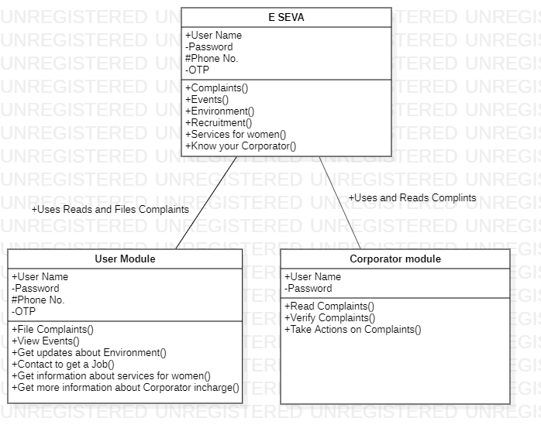

**Use Case Diagram:**

User Module:

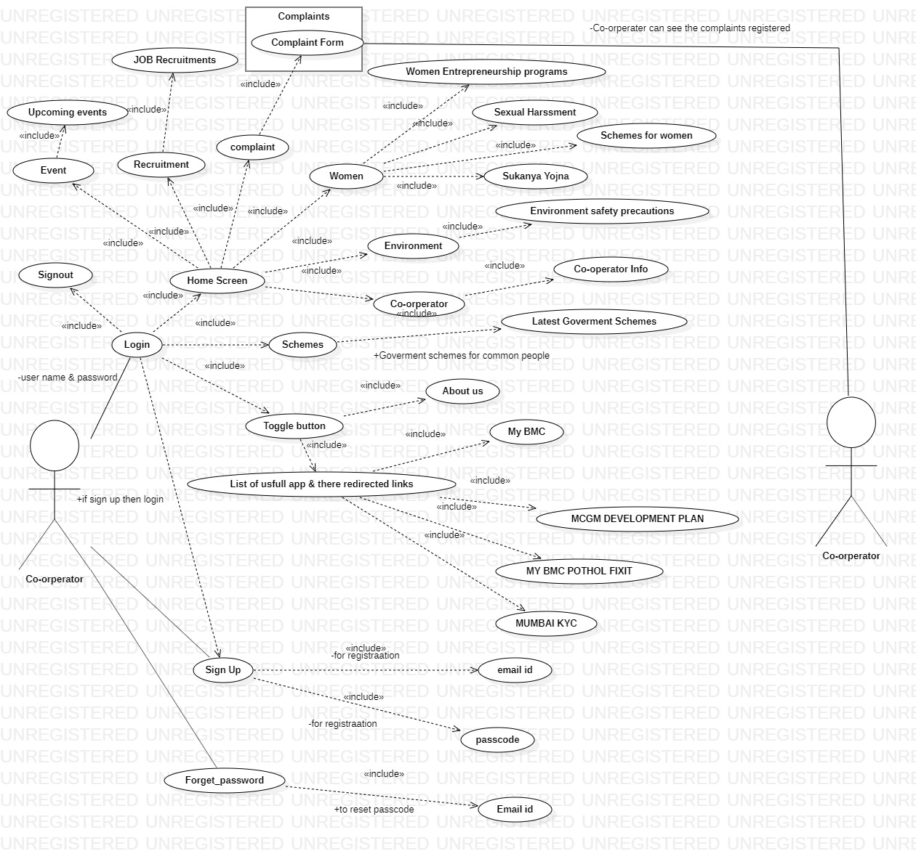

Corporator Module:

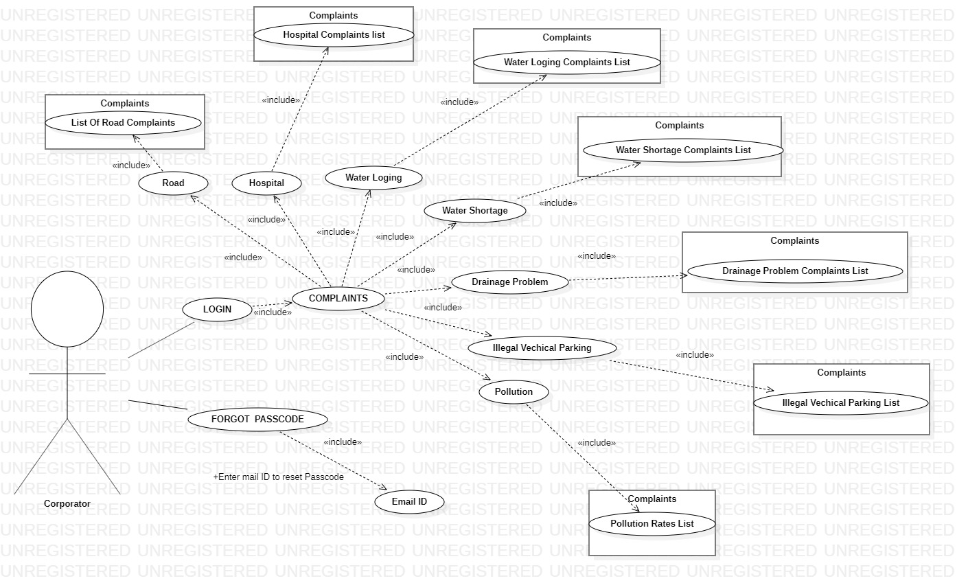

CHAPTER 6

Database Structure

# Database Structure

* 1. **Authentication:**

Firebase Authentication provides backend services, easy-to-use SDKs, and ready-made UI libraries to authenticate users to your app.

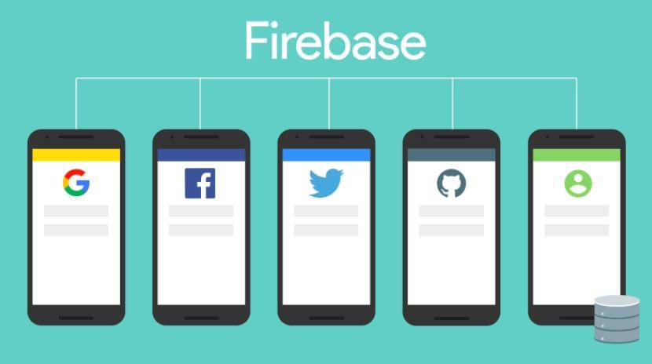

Normally, it would take you months to set up your own authentication system. And even after that, you would need to keep a dedicated team to maintain that system. But if you use Firebase, you can set up the entire system in under 10 lines of code that will handle everything for you, including complex operations like account merging.

You can authenticate through the following methods:

**For User Module**

* Email & Password

Email & Password for user can be his own gmail id or he can create one using our applications sign in page by the available or created email and password the user can login into the application and make out of use of the application.

* Phone numbers

Using Firebase Authentication makes building secure authentication systems easier, while also improving the sign-in and onboarding experience for end users.

Firebase Authentication is built by the same people who created Google Sign- in, Smart Lock, and Chrome Password Manager.

**For Corporator Module**

* Email & Password

Email & Password will be provided by the IT cell of the BMC by the use of which the Corporator can login and use the E-SEVA application.

* 1. **Storage:**

For storage Firebase is used the storage includes the complaints registered by the users the forms data filled by the users to register their respective compiants

CHAPTER 7

Coding

# Coding

For coding the “E-SEVA” application resources used where:

* 1. Integrated Development Environment (IDE) i.e Android Studio
  2. Database i.e

For Authentication – Firebase

For Storage – MySQL (phpMyAdmin)

* 1. GitHub for version control

7.4 Languages used are:

1. Java:

Android applications are developed using the Java language. Java is a very popular programming language developed by Sun Microsystems (now owned by Oracle).Java incorporates many of the powerful features of those powerful languages while addressing some of their drawbacks.

Android relies heavily on these Java fundamentals. The Android SDK includes many standard Java libraries (data structure libraries, math libraries, graphics libraries, networking libraries and everything else you could want) as well as special Android libraries that will help you develop awesome Android applications.

Some of the Java’s important core features are:

* It’s easy to learn and understand
* It’s designed to be platform-independent and secure, using  
  virtual machines
* It’s object-oriented

For our application java consist the backend logic and connection to database i.e firebase

1. XML:

XML stands for Extensible Markup Language. XML is a markup language much like HTML used to describe data. XML tags are not predefined in XML. We must define our own Tags. Xml as itself is well readable both by human and machine. Also, it is scalable and simple to develop. In Android we use xml for designing our layouts because xml is lightweight language so it doesn’t make our layout heavy.

1. Database:

The Firebase Real time Database is a cloud-hosted database. Data is stored as JSON and synchronized in real time to every connected client. The Firebase Real time Database lets you build rich, collaborative applications by allowing secure access to the database directly from client-side code. Data is persisted locally, and even while offline, real time events continue to fire, giving the end user a responsive experience. When the device regains connection, the Real time Database synchronizes the local data changes with the remote updates that occurred while the client was offline, merging any conflicts automatically.

CHAPTER 8

Testing

# Testing

[Use this formatting. Font Type: Arial, Font Size: 12 Paragraph Setting: Alignment: Justified, Indentation: Left: 0 cm, Right: 0 cm Special: First Line, Spacing: Before: 0 cm, After: 0 cm, Line Spacing: 1.5, ]

CHAPTER 9

Output/Screenshots

# Output/Screenshots

* **E-SEVA**

**Home Page**

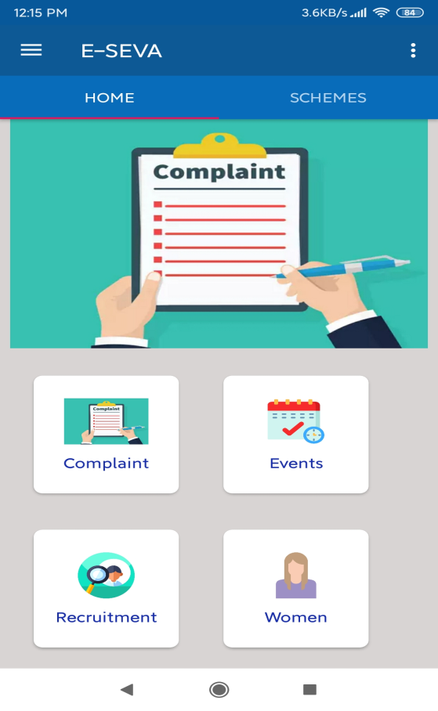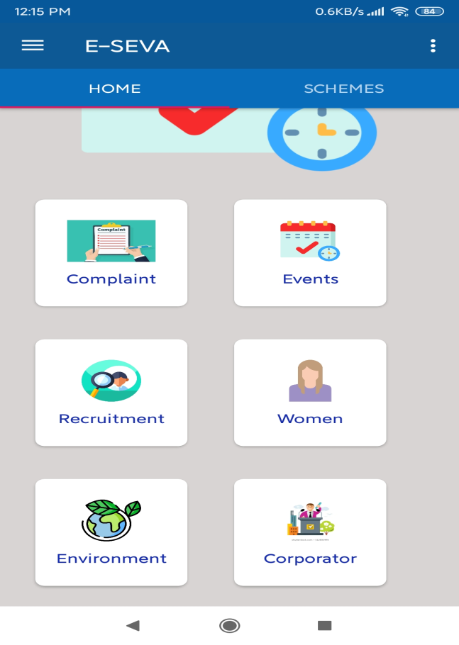

**Complaints**

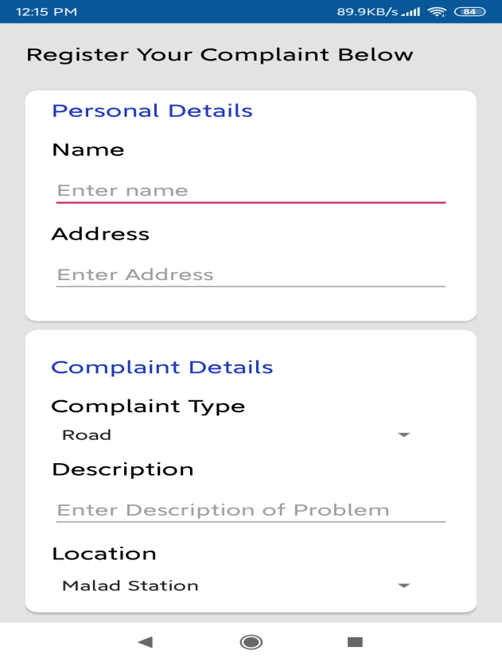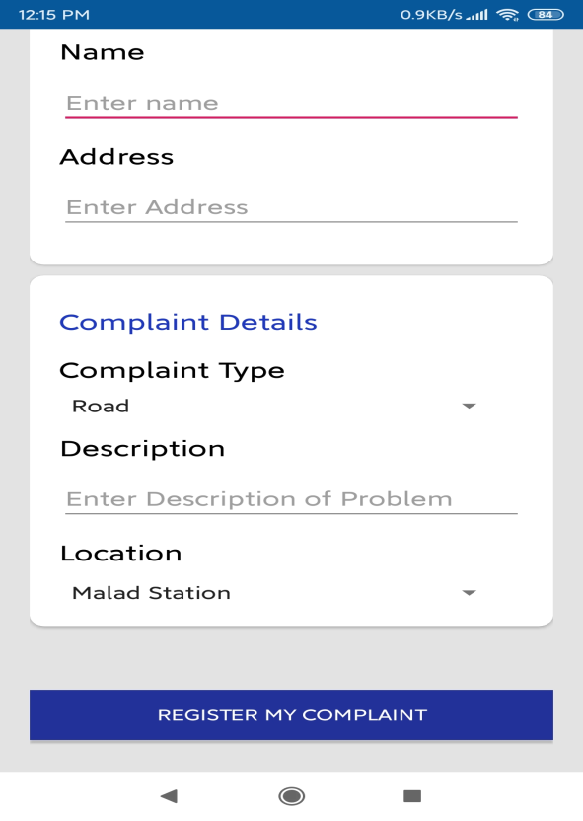

**Events**

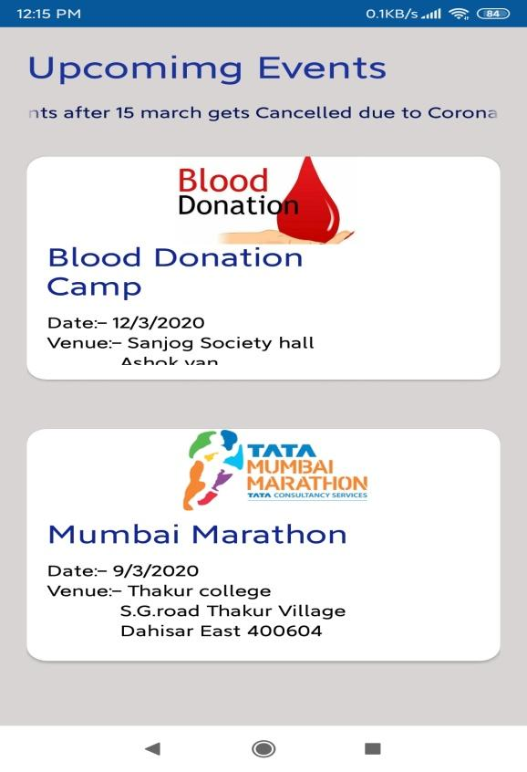

**Recruitments**

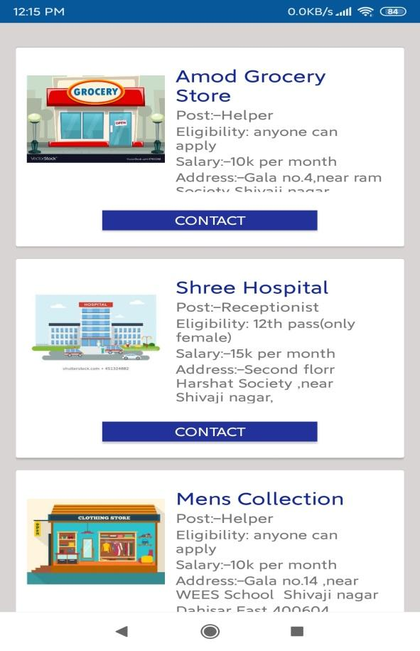

**Women**

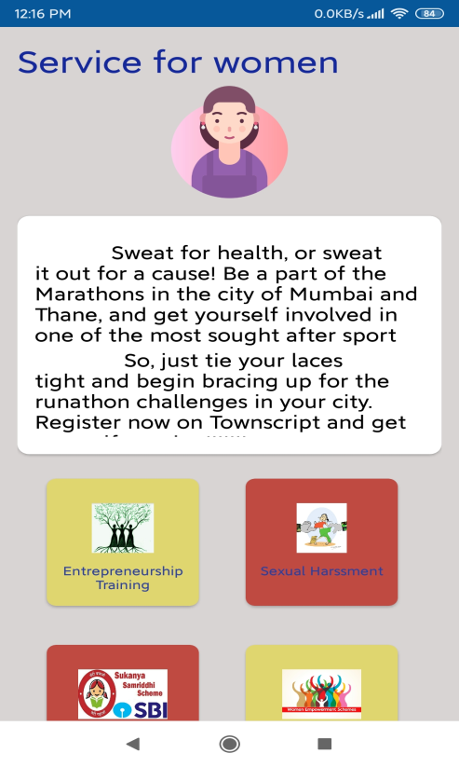

**Environment**

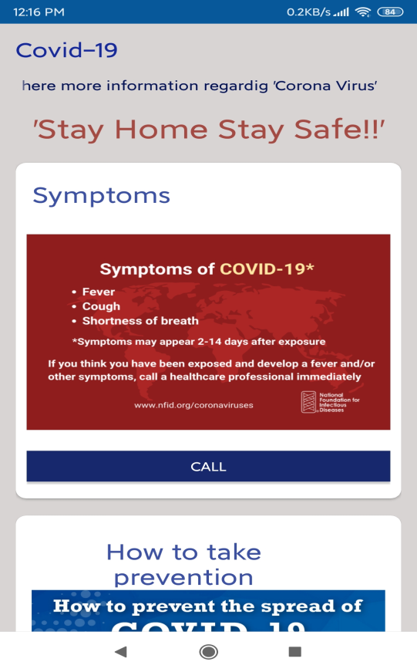 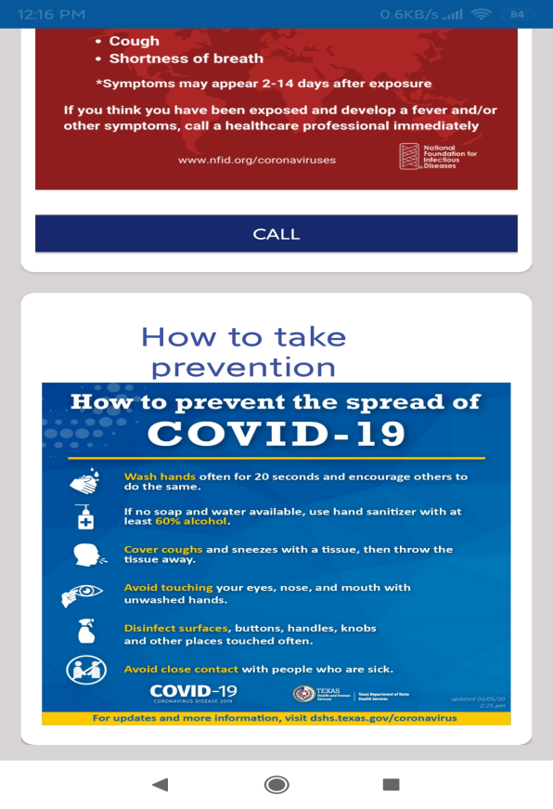

**Corporator**

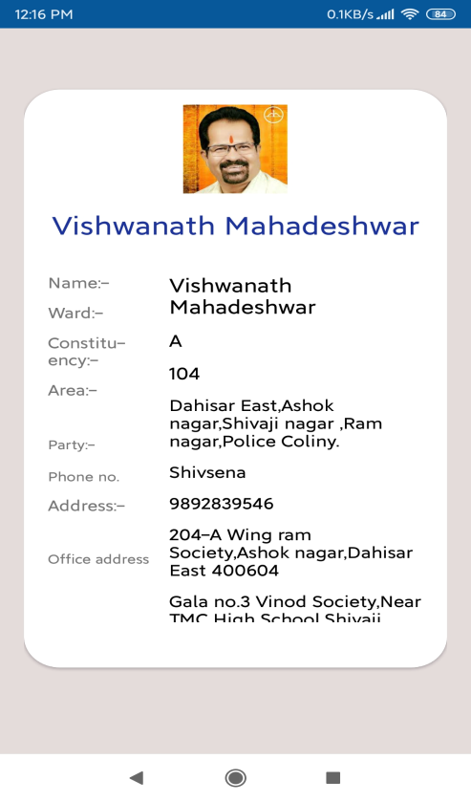

**Schemes**

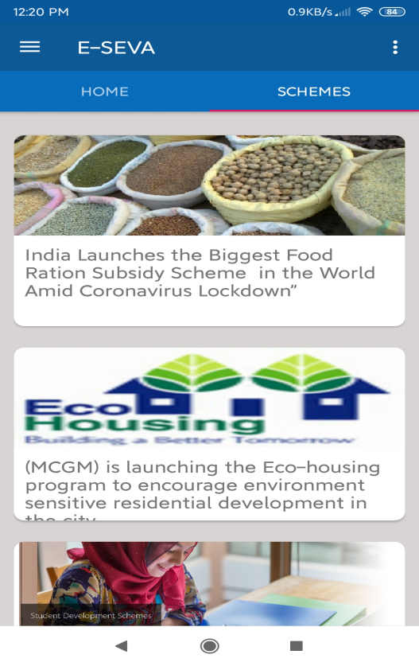

* **Corporator Module**

**Home**

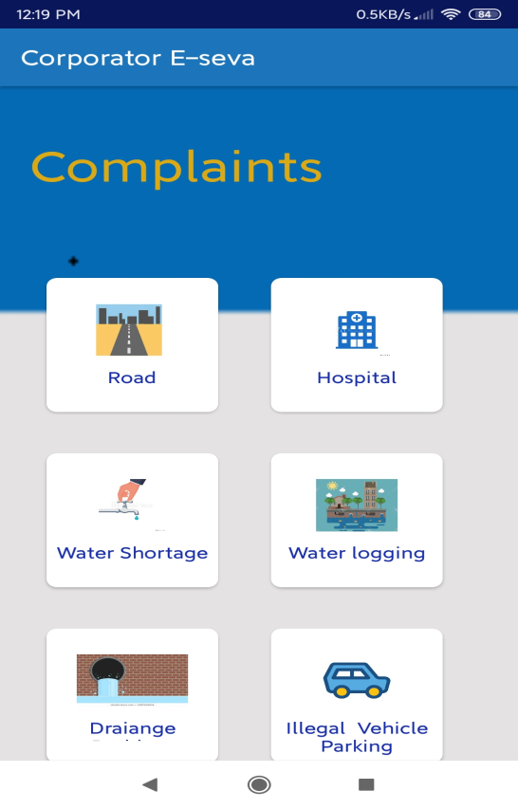

**Problem**

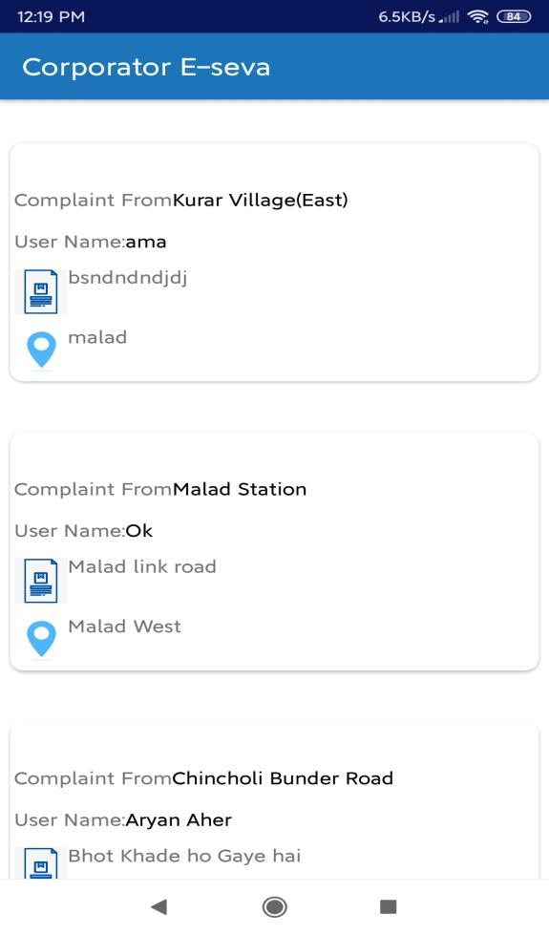

Conclusion

**Conclusion**

1. By the use of this application “E-SEVA” the gap between local peoples and Corporator will be decreased drastically.
2. People can fill complaints and problems like Electricity, water, road easily from the application.
3. People can track the environmental issues in their surroundings.
4. Women will know the all information about “women saving pool” and other related services provided for them by BMC. Local people will know the all information of their respective Corporator.
5. If there are any corporate or local jobs available they can be informed and can contact to them from the application.